Geometry: Unit 4, Lesson 2
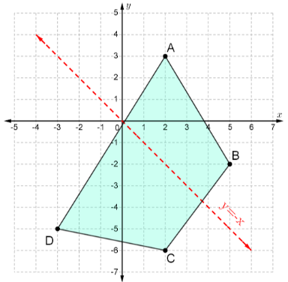
- What point will the image of vertex $B$, on quadrilateral $ABCD$, be located at after a reflection over the $y=-x$ line?

$$(2, -5)$$

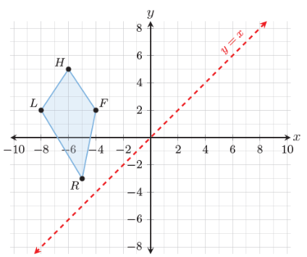

- After reflecting quadrilateral $FHLR$ over the $y=x$ line, where will the new point $F$ be located at?

$$(2, -4)$$
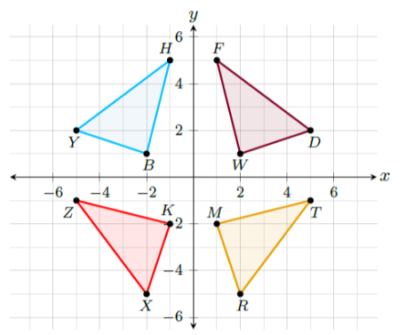
- Triangles $YBH$, $DWF$, $RMT$ and $XKZ$ are shown on the coordinate grid. To transform $∆YBH$ into $∆RMT$, what must you do to $ΔYBH$?

Reflect $ΔYBH$ over the $y=x$ line

